Tables

The operation of "looking something up in a table" occurs very frequently in most areas of computing.

Examples
when you log in, your user-id is looked up in a table to find your password and home directory;
BT's directory enquiry system;
medical records systems;
Gas and Electricity Board consumer accounting systems;
stock control;
etc . . . .

Terminology

The field used to identify the data item wanted is called the key or the index of the table. Data items held within the table are referred to as entries. If it can be guaranteed that there will be at most one entry corresponding to a given key, the keys are said to have the unique identification property.

The Table ADT

Insert given a key and an entry, inserts data into the table;
Delete given a key, removes the entry associated with that key.

Locate returns an entry associated with the key;
Exists tests to see if a key is in table;

Iterate visit all the items one at a time, allowing the user to retrieve information. The order may or may not be defined.

Factors Influencing Choice Of Representation

the volatility of the table (i.e. how often entries get inserted and deleted);
the density of the keys (i.e. how many of the possible key values are likely to be used);
the pattern of accesses (e.g. will most of the accesses be to just one or two key values);
whether or not the table is small enough to fit in RAM;
the lifetime of the table.

Simple Implementation

One of the simplest implementations is to use an array in which we store entries contiguously (side by side). We keep a record of the next available location to insert into.

Insertion - the location of the entry in the table is not based on key but instead is put into the next available free space. The key is actually used in Insertion but only to check for duplicates.

Deletion – this involves a linear search through the table looking for the required entry- the key is used to check for the correct entry. When it is found we replace this entry with the last in the array (or shunt the array down, which is much slower).

Locate – again a linear search through the array checking against keys

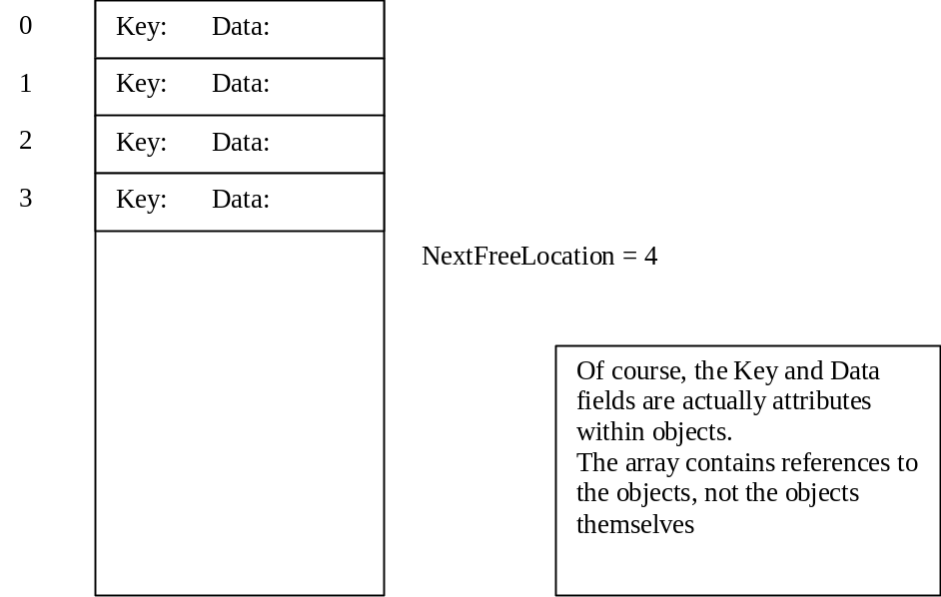

The Keyable interface

In order to ensure that our objects have a key, we can define a simple interface which they must implement:

/**
* An interface to support tables.
* To be keyable, we must provide a method, which when given an object,
* generates a key from the objec.
* This key can then be used for insertion, retrieval etc.
* @author M. Ratcliffe
* @version 20/10/98
*/

public interface Keyable
{
public abstract String getKey();

}

And now for the code of Table

/**
* Table provides a simple insertion/deletion & retrieval operation
* based on a table.
* All entries are associated with a key which must be unique.
* Keyable interface guarantees that getKey is available.
* Simple implementation just inserts items as they arrive
* @author Mark Ratcliffe
* @version First written 31/10/98
*/

public class Table
{
private Keyable[] contents;

// Simple implementation -- nextFreeLocation indicates next free location
private int nextFreeLocation = 0;

/**
* DEFAULT_SIZE (100) sets default size of table.
*/
public static final int DEFAULT_SIZE = 100;

/**
* Table default constructor creates table of DEFAULT_SIZE
*/
public Table()
{
contents = new Keyable[DEFAULT_SIZE];
}

/**
* Table constructor creates table of specified size
* @param theSize - an integer representing size of table
*/
public Table(int theSize)
{
contents = new Keyable[theSize];
}

/**
* exists checks to see if theKey already exists in the table.
* Note: This simple, inefficient implementation has no ordering
* @param theKey - String to be checked against
* @return boolean - true if theKey is found in table
*/
public boolean exists(String theKey)
{
try
{
Keyable temp = this.locate(theKey);
// If we get this far, it must exist
return true;
}
catch (TableEntryNotFoundException e)
{
return false;
}
}

/**
* insert places theObject in next free location in table.
* Note: This simple, inefficient implementation has no ordering
* @param theObject - a Keyable object to be inserted
* @exception TableFullException thrown if table is full
* @exception TableDuplicateKeyException thrown if key is not unique
*/
public void insert(Keyable theObject)
throws TableFullException, TableDuplicateKeyException
{
// first test for duplicate entries
if (this.exists(theObject.getKey()))
{
throw new TableDuplicateKeyException();
}

if (nextFreeLocation == contents.length)
{
throw new TableFullException("Table is full");
}
contents[nextFreeLocation] = theObject;
nextFreeLocation++;
}

/**
* locate will find an object given a key
* @param theKey - a string which indentifies the object
* @return Object - the object that has been located in the table
* @exception TableEntryNotFoundException thrown if key not found
*/
public Keyable locate (String theKey) throws TableEntryNotFoundException
{
// Search table upto currentLocation
for (int count=0; count < nextFreeLocation; count++)
{
if (contents[count].getKey().equals(theKey))
{
return contents[count];
}
}
// If we get here then we have searched the table without success
throw new TableEntryNotFoundException("Key not present");
}

/**
* delete will remove an object from the table given a key
* @param theKey - a String which identifies the object
* @return Object - the object that has been located in the table
* @exception TableEntryNotFoundException thrown if key not found
*/
public void delete (String theKey) throws TableEntryNotFoundException
{
// First find object by searching table upto nextFreeLocation
int foundAt = 0;
boolean found = false;
while ((foundAt < nextFreeLocation) & (found == false))
{
if (contents[foundAt].getKey().equals(theKey))
{
found = true;
}
else
{
// Not found so increment counter for search
foundAt++;
}
}
if (found == false)
{
throw new TableEntryNotFoundException("Key not present");
}

// reduce nextFreeLocation - remember it points to next free slot
nextFreeLocation--;
// swap found item with item at end (saves shunting)
contents[foundAt] = contents[nextFreeLocation];
// delete reference to deleted object at end of table
contents[nextFreeLocation] = null;
}

/**
* getLength passes back the current number of entries in table
* @return Integer representing the number of entries in table
*/
public int getLength()
{
return nextFreeLocation;
}

/**
* toString produces a formatted string representing table
* @return String the formatted string representing table
*/
public String toString()
{
String temp = "\n";

for (int count = 0; count < nextFreeLocation; count++)
{
temp = temp + "\n" + count + "\t" + contents[count].toString();
}
return temp;
}
}

For an example of using this see KeyableExample.java

Analysis of Simple Implementation

If the pattern of accesses is random, then the time complexity of all operations is O(n/2), where n is the number of items in the table. If insertion checks for duplicates, its performance will be O(n).

We can use the same idea but substitute a linked list for the array. Deletion then becomes easier and removes the need to specify the maximum size of the table. This method is only acceptable if n is very small (e.g. < 5).

In the case that the key is an integer, we could use this as our index into an array. In this case, all the operations become trivial - we need to think carefully about what Insertion and Deletion mean in this context. The number of values in key must not be too large - and we shall loose a lot of space if the keys are not very dense. It would not be sensible if the key was a telephone number!

Binary Chopping

Consider how we look up a number in a telephone directory. The essential point is that the directory is in alphabetical order. We can open it up to roughly where we think we will be able to find the number and then work forward or backward as appropriate. If we hold our table in an array ordered by keys, we can produce a program that works in the same sort of way. We can go to the middle of the table and decide whether the key we want is in the upper half or the lower half. We then go to the midpoint of that half and repeat the process. We keep doing this until we find the key.

Consider searching for Richard in the following table:
Alan
Fred
Joe
Margaret
Mary
Monica
Nick
Nicola <---- First midpoint
Olivia
Peter <---- Third midpoint
Richard <---- Fourth midpoint
Russell <---- Second midpoint
Thomas
Timothy
Xavia

We find Richard with 4 comparisons rather than 11 if we had searched sequentially.

public Keyable locate (String theKey)
throws TableEntryNotFoundException
{
int top = nextFreeLocation -1;
int bottom = 0;
int mid = 0;
boolean found = false;

while ((!found) & (top >= bottom))
{
mid = (top + bottom) / 2;
if (theKey.equals(contents[mid].getKey()))
{
found = true;
}
else
{
if (theKey.compareTo(contents[mid].getKey()) < 0)
{
// it's less than the one we found, so search below
top = mid -1;
}
else
{
// it's bigger than the one we found, so search up
bottom = mid + 1;
}
}
}
if (found)
{
return contents[mid];
}
else
{
throw new TableEntryNotFoundException();
}
}

For more details see SortedTable.java and SortedTableDemo.java

Performance of Binary Chopping

Since we know the size of the subtable, at each step the maximum number of comparisons we have to make is: the number of times that n can be halved before we reach 1 i.e: log₂n (i.e. the smallest integer greater than or equal to log₂n).

Hashing

The above example shows that if the keys for a table are dense, we can use an array of entries, indexed by the keys, as an efficient implementation technique. Hashing is a method of getting most of the advantages of this method in the case that the keys are sparse

The technique is also known as:
address calculation;
scatter storage;
key transformation;

Suppose that we need a table of entries concerning applicants to the department, indexed by the applicants' UCAS numbers. We know that we shall never be dealing with more than 1000 applicants.

We can specify an array:
Keyable[999];

If we take the last three digits of a candidate's UCAS number, we can use it to select the element of the array in which his details are found.

89001526
^^^

The operations on the table can be very fast (essentially only one access operation is required) but what happens if two applicants have UCAS numbers ending in the same three digits? This is known as a collision. The simple way of handling collisions, when inserting a new applicant, is to search forward from the element the applicant should be in, until we find an empty element. When searching, we do the same thing, moving forward until we find the applicant that we want.
(We need to treat the table as circular).

Index | Key | Entry | Data
0 | 1312000 | Jones
1
2 | 1524002 | Roberts
3
4
997 | 1562997 | Smith
998 | 1892998 | Jones
999 | 1241999 | Green

1307997 Owen will be inserted in location 1.

If there were already 999 applicants in the table, then inserting the 1000th would probably involve a long search to find the free place. More generally, as the table fills, collisions occur more often. The table size should be big enough to ensure that the table doesn't become too full. When the table becomes about half full, the method of collision resolution can cause clustering i.e. long strings of adjacent records with gaps between the strings. Again this will make performance poor. The collision resolution method should obviate clustering.

This example illustrates all the main features of hashing.
In general we need to;
determine a suitable size for the table;
find a suitable hashing function which transforms the keys into integers in the range of the table size;
find a suitable method of handling collisions.

In order to understand what is meant by suitable, we have to look at what might go wrong.

Suppose that UCAS numbers are determined in such a way that the last two digits indicate the year in which the applicant first applies. In 1989, almost all of the applicants would have UCAS numbers ending in 89 and so would map on to the elements 089, 189, 289, 389,...,989. The result would be, in effect, that we had 10 lists beginning at these points, one of which we would have to search sequentially in each case. The performance would become very poor. The hashing function must map the keys UNIFORMLY and RANDOMLY onto the range 0..(TABLE_SIZE - 1).

Choosing a hash function
Truncation
Ignore part of the key and use the rest as the array index (converting non-numeric fields). This works well and is fast, provided that the key has the right properties of uniformness and randomness.

Folding
Partition the key into several parts and then combine them in any convenient way.
E.g. with a 9-digit key, split into three lots of three and add them:

925376622 => 925 + 376 + 622 = 1923

Usually better than truncation as it uses information from the whole key.

Modular Arithmetic
Almost always used as a last stage after truncation or folding. It can also be used by itself. Convert the key into an integer in some convenient way. Divide by the table size and take the remainder as the index. This is referred as doing arithmetic modulo the table size. The notation x mod n means the remainder when x is divided by n. If the table size is a power of a small integer such as 2 or 10, this will give a lot of collisions. Best to use a prime number e.g. 997 or 1009, rather than 1000 or (even worse) 1024.

Assume TABLE_SIZE = 98000

key: 1 123 456 789

key/98000 = 1259 remainder34 789
last 3 digits of key are unchanged.

Any number divided by 98000 will give the remainder with unchanged keys.

Randomisation will be incomplete especially if some coding is used e.g. year of entry.

Divisor should not be divisible by 2, 3, 5, 10 or their simple multiples. Division by primes - every digit in number is involved in division process.

Examples of Hashing Functions

Key: Telephone number
The last three digits are always random and uniform so these can be used. If a bigger table is needed, then we can use folding and modular arithmetic. Higher order digits are not uniform and depend on the telephone area.

Key: Peoples' names
This is difficult because many people have the same surname. If you will always have the correct full name, then parts of all names can be used e.g.
Edward Carl Smith
^^ ^^ ^^ dw ar mi

Use as a base 29 number (a=1, b=2,...) taking the result modulo the (prime) table size.

Example code

Take a look at OpenAddressing.java and HashingExample.java

Notes on Deletion

If open addressing is used, deletion presents a problem. Having located the entry to be deleted, it is not enough to mark the place empty. An empty place will stop the search for other keys that have been hashed to the same place. It is necessary to have an extra flag in each table entry indicating that the place is empty but probing must continue. This is the reason for our inner class!

Note: This can lead to inefficiencies and reorganising the table is time consuming.

Index | Key | Entry | Data
0 | 1312000 | Jones
1 | 1307997 | Owen
2 | 1524002 | Roberts
3
4
997 | 1562997 | Smith
998 | 1892998 | Jones
999 | 1241999 | Green

If we delete 1892998 (Jones) then we must still be able to get 1307997 (Owen).

Collision Resolution

The process of looking for a key at a specific point in the table is known as probing. The time complexity of collision resolution techniques is usually measured by the average number of probes required to locate an entry. The method we described for UCCA numbers is called linear probing.

Why does linear probing lead to clustering?

a b c d e f g h i

In n = TABLE_SIZE, then if the table is empty, the probability of the next entry going to any particular place is 1/n.

In the diagram, the probability of b getting filled next is 3/n (either a hash to a or to b or even i fills it).
Once b is full, the probability of d being filled next is 5/n and then of g is 8/n (i.e. the probability of getting long strings steadily increases).

One good way of resolving collisions is to use quadratic probing.

If there is a collision at element h, then instead of probing at:

h + 1; h + 2; . . (mod n)

as in linear probing, we probe at:

h + 1², h + 2², h + 3², . . (mod n)

Coverage

Linear probing guarantees that we do probe the whole table before declaring it full (when inserting).
Quadratic probing does not guarantee this:

e.g. n=16, h=3 gives the sequence: 3, 5, 7, 12, 3 so we only probe 1/4 of the table.

However if we make n prime, one can prove that half the table will always be in the sequence.

Linear probing and quadratic probing, in which all the entries are directly addressed in the table, are called open addressing methods.

An alternative, which is often very useful, is collision resolution by chaining. In this case, instead of an array of entries we use an array of pointers. Each element of the array points to the head of a linked list containing the entries that hash to that element.

0
0

2431002 Roberts
1165999 Evans
1204998 Jones
1311997 Smith

131200 Jones

1307997 Owen

997

998

999

Collision avoidance by chaining has many advantages:
collision handling is simplified and there is no problem of clustering; if the entries are large, we save a significant amount of space because we only use space for the entries actually present;
the number of entries can be bigger than the number of elements in the array;
deletion is simplified.

If the size of the entries is small (e.g. one word) the overhead of storing the links may be significant. In some cases it is better to use the space to have a bigger table using open addressing (bigger table reduces collisions).

Performance of Hashing

The number of probes depends on the load factor (usually denoted by λ) which represents the ratio of entries present in the table to the number of positions in the array.

We also need to consider successful and unsuccessful searches separately.

For a chained hash table, the average number of probes for an unsuccessful search is λ and for a successful search is 1 + λ/2

Unsuccessful

n = number of items
t = number of chains

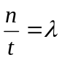Average items in a chain:

Unsuccessful search means a key comparison on every item in a chain.
i.e. λ comparisons.

Successful

First we need the average number of key comparisons in a sequential search on a list of length k:

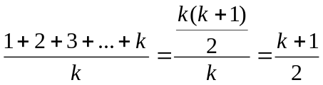

Successful search means the chain contains at least one item (the target).

With random distribution of the other (n - 1) items over the t chains, the expected length of the target chain is:

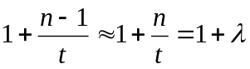
Average number of comparisons is:

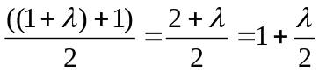
For open addressing, the formulae are more complicated but typical values are:

Load Factor | 0.1 | 0.5 | 0.8 | 0.9 | 0.99
Successful search
Linear Probes | 1.05 | 1.6 | 3.4 | 6.2 | 21.3
Quadratic Probes | 1.04 | 1.5 | 2.1 | 2.7 | 5.2
Unsuccessful search
Linear Probes | 1.13 | 2.7 | 15.4 | 59.8 | 430
Quadratic probes | 1.13 | 2.2 | 5.2 | 11.9 | 126

Note that these do not depend on the size of the array or the number of entries present but only on the ratio (the load factor).

